* **GENIISYS Workspace Backup**
  + Backup of Geniisys workspace folders.
  + Backup is saved in RCM Hard Drive.
  + Done every Friday.

STEPS:

1. Update every projects in repository (*Eclipse*).

**v1.0-Geniisys**  - https://subversion.assembla.com/svn/cpi_geniisysweb/branches/v1.0/Geniisys

**-baseline-GeniisysDB** - https://subversion.assembla.com/svn/geniisys_db/branches/baseline/GeniisysDB

**-baseline-GeniisysReports** - https://subversion.assembla.com/svn/geniisys_reports/branches/baseline/GeniisysReports

**-GeniisysConfigurablePackages** –

https://subversion.assembla.com/svn/geniisysconfigurablepackages/trunk/GeniisysConfigurablePackages

**-GeniisysConfigurablePReports** –

https://subversion.assembla.com/svn/geniisysconfigurablereports/trunk/GeniisysConfigurableReports

**gencsscript** - https://subversion.assembla.com/svn/gencsscript

**UCPBGEN_GeniisysDB** - https://subversion.assembla.com/svn/geniisys_db/branches/release/v0.4-02082013-devt

**UCPBGEN_Geniisysweb** - https://subversion.assembla.com/svn/cpi_geniisysweb/branches/release/v0.4-02082013-devt

**-RSIC_GeniisysDB** - https://subversion.assembla.com/svn/geniisys_db/branches/release/v0.3-10012012-devt

**-RSIC_Geniisysweb** - https://subversion.assembla.com/svn/cpi_geniisysweb/branches/release/v0.3-10012012-devt

**-PHILFIRE_GeniisysDB** - https://subversion.assembla.com/svn/geniisys_db/branches/release/v0.6-06172013-devt

**-PHILFIRE_Geniisysweb** - https://subversion.assembla.com/svn/cpi_geniisysweb/branches/release/v0.6-06172013-devt

Right Click > **Team** > **Update To HEAD** 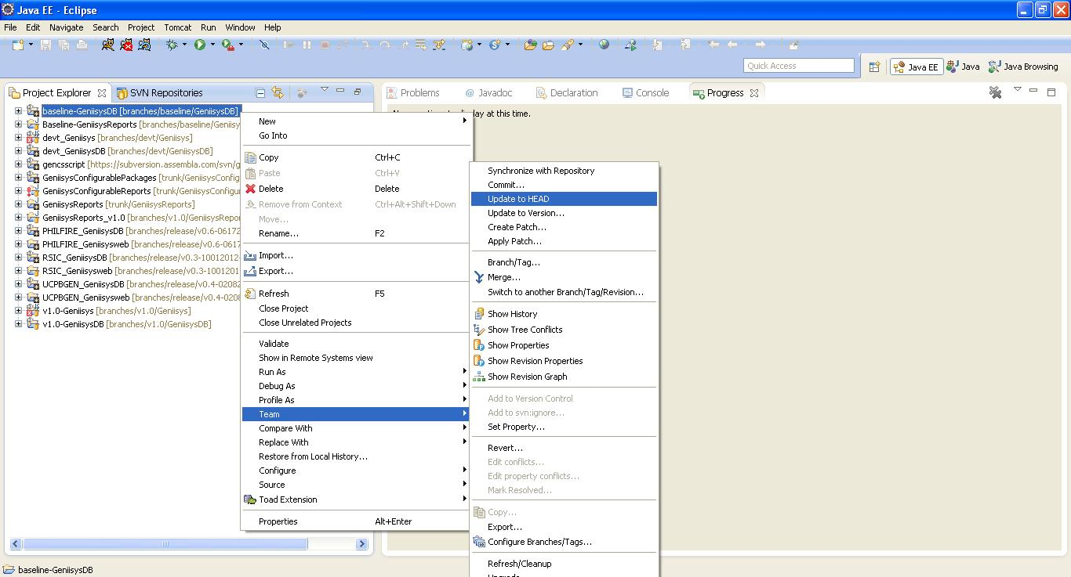

1. Open **Geniisys workspace folder** from your local drive. (*Ex. C:\Geniisys RCM workspace*)

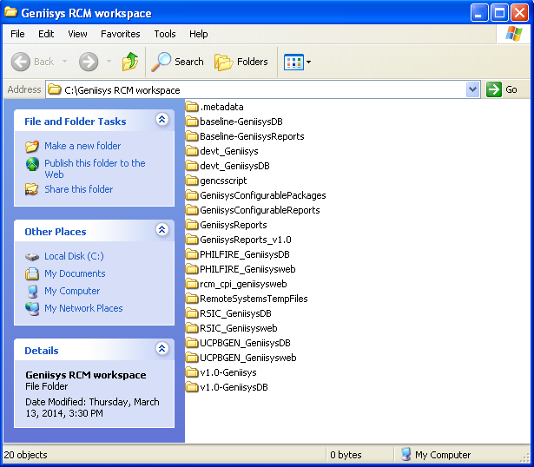

1. Create a Folder in **RCM Hard Drive** (*Format: “backup MM-DD-YYYY”*).
2. Copy all folders from **Geniisys workspace folder** To **newly created folder in RCM Hard Drive**.

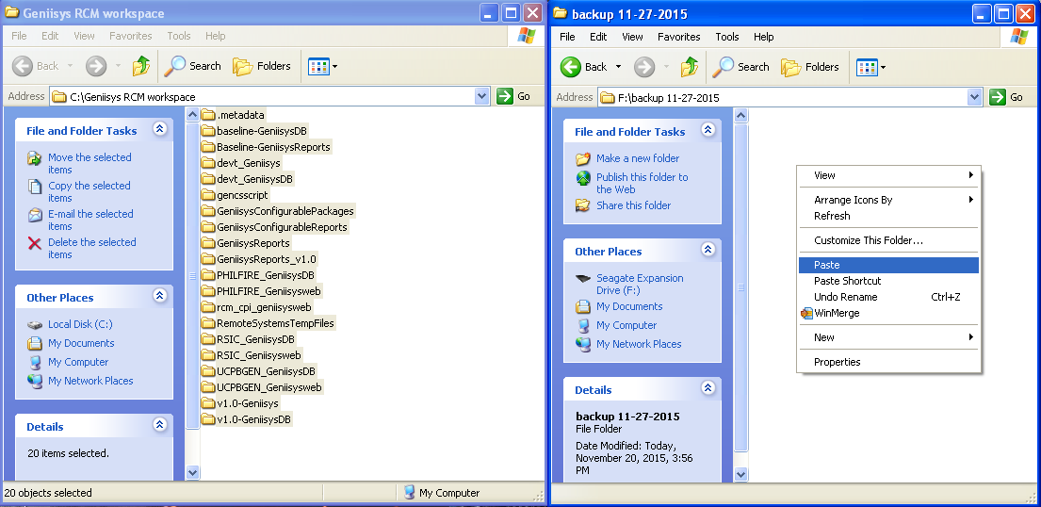

* **GENIISYS Web Apps and DB backup**
  + Backup of Geniisys web apps folder in Baseline 110, Baseline War file and Baseline Dump.
  + Backup location is in \\Rcm-server\upload$\GENIISYS WEB APPS AND DB.
  + Done every Monday.

STEPS:

1. Create Folders in *\\Rcm-server\upload$\GENIISYS WEB APPS AND DB\date of backup (format: MM-DD-YYYY).*

* Geniisys
* War
* Dump

**2. Geniisys Web Apps backup:**

1. Connect in **192.10.10.110** thru Remote Desktop.

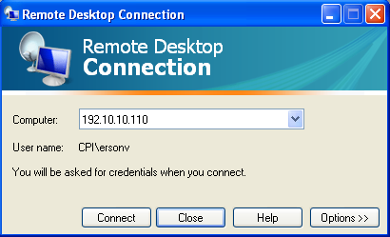

1. In 192.10.10.110, Copy **Geniisys** folder from

***C:\Program Files\Apache Software Foundation\Tomcat 7.0_Tomcat7_BASELINE_10\webapps***

To

***\\Rcm-server\upload$\GENIISYS WEB APPS AND DB\ MM-DD-YYYY***

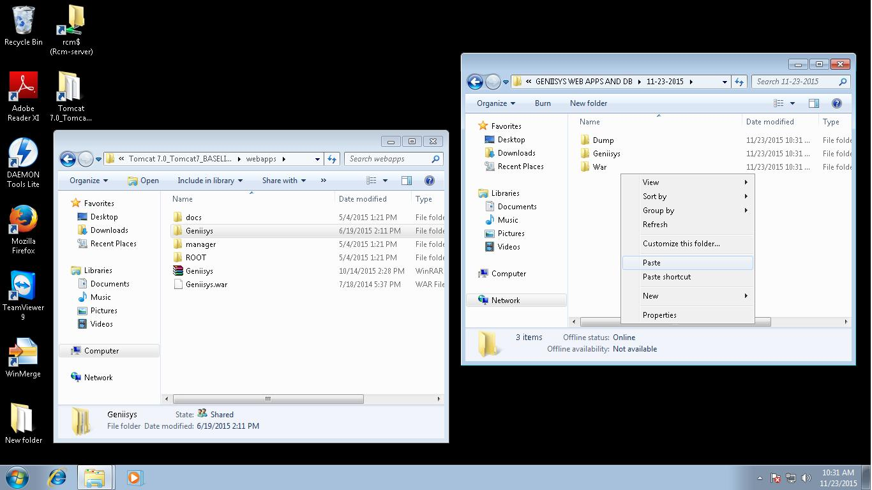

**3. Generating Baseline War file:**

1. Update baseline (v1.0-Geniisys) in repository (*Eclipse*).

Right Click > **Team** > **Update To HEAD**

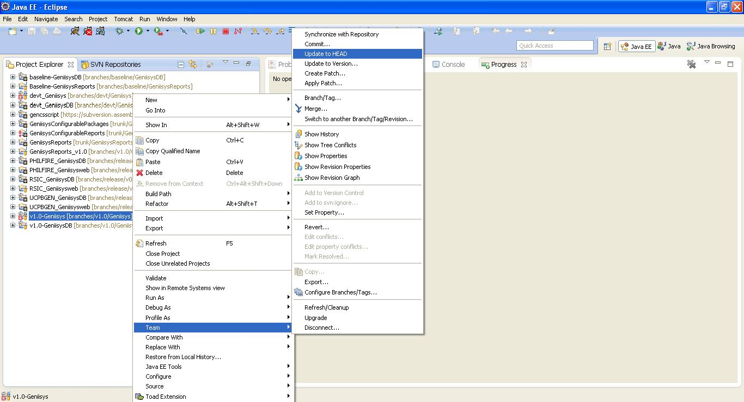

1. Export War File.

Right Click > **Export** > **WAR File**

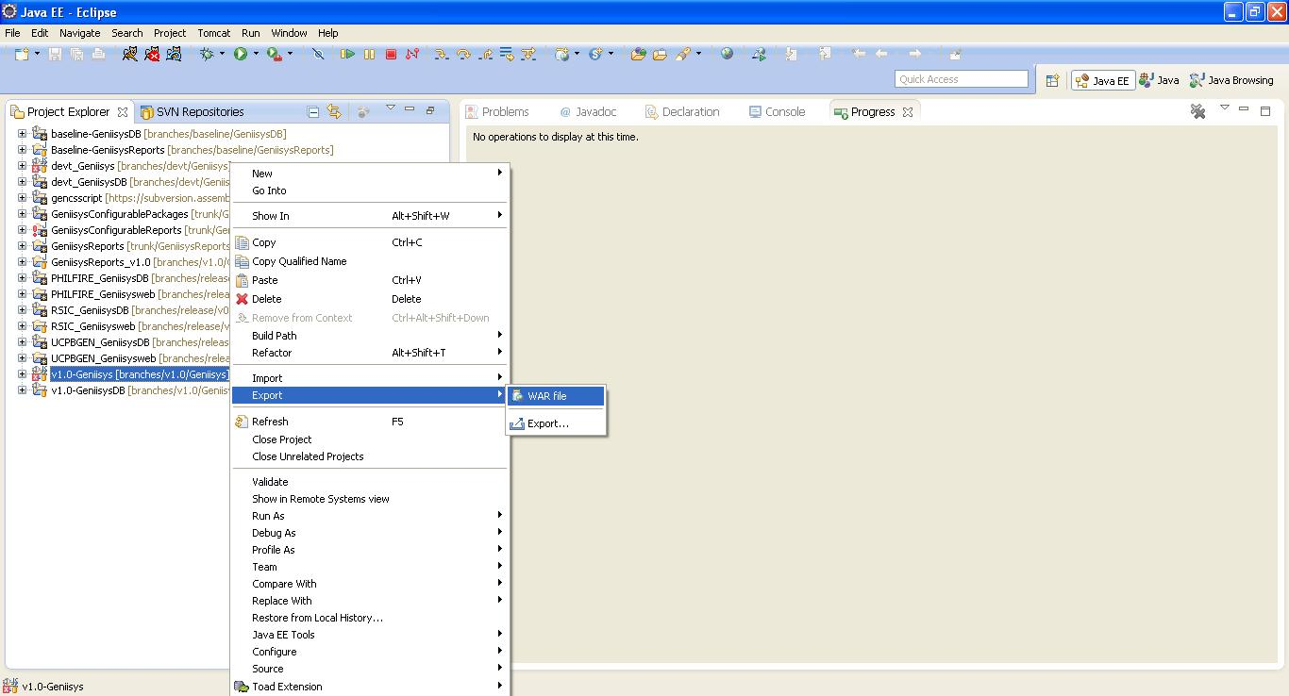

1. WAR Export details:
2. Enter backup location in Destination field;

***\\Rcm-server\upload$\GENIISYS WEB APPS AND DB\ MM-DD-YYYY\War\***

1. Select **Export Source Files** checkbox.
2. Click Finish.

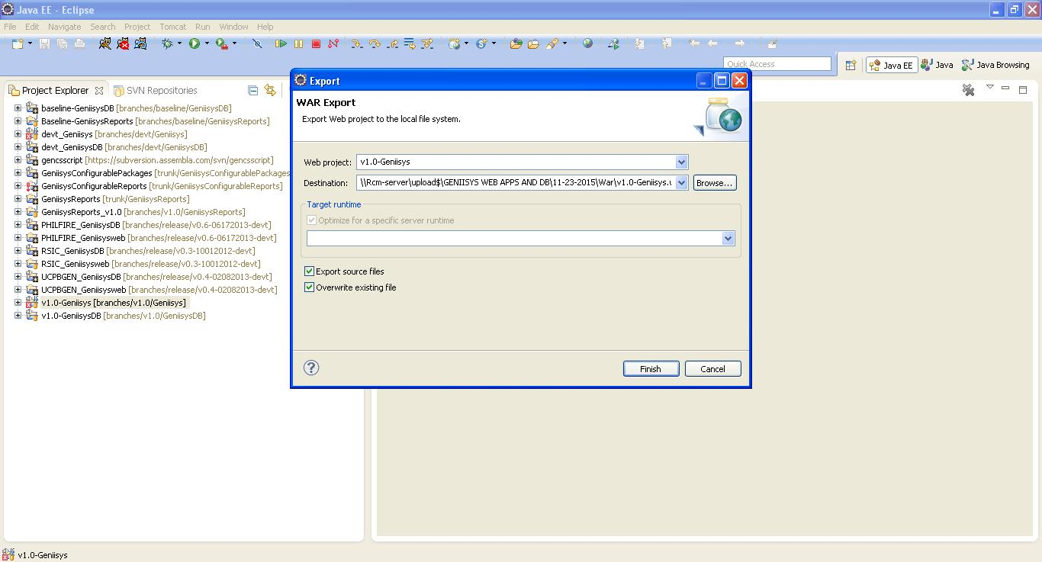

**4. Baseline Dump backup:**

1. We can access the baseline dump in ***\\Dba-server\baseline***
2. Copy the folder with specific date of baseline dump from ***\\Dba-server\baseline***

To ***\\Rcm-server\upload$\GENIISYS WEB APPS AND DB\ MM-DD-YYYY\Dump\***

**5.** Compress all folders (Geniisys, WAR, Dump) to a .rar file.

**6.** Send e-mail In ***[RELEASE] GenIISys Webapps + Dump + WAR File*** thread with release date, location of the files and name

of Release Engineer.

Sample Format:

11-23-2015 Release:

**\\Rcm-server\GENIISYS WEB APPS AND DB\11-23-2015**

Released by: Erson